FINTRUST FINANCIAL INTELLIGENCE & DIGITAL BANKING SUPPORT SOLUTION
WEEK 1 — BUSINESS & DATA INTELLIGENCE ASSESSMENT
Track: Data Analytics
Project: FinTrust Financial Intelligence & Digital Banking Support Solution.
Theme: Understand → Explore → Define → Plan
Prepared by: Victoria Kosgei
Date: September 2026

Contents
FINTRUST FINANCIAL INTELLIGENCE & DIGITAL BANKING SUPPORT SOLUTION i
1. Executive Summary 1
2. Business Understanding 1
2.1 Key Business Questions 1
2.2 Decisions Supported by Data 2
2.3 Key Stakeholders 2
3. Resource Review 2
4. Data Understanding & Profiling 3
4.1 Customer Dataset 3
4.2 Transaction Dataset 3
4.3 Dataset Relationship 5
5. Initial Data Quality Assessment 5
6. Analytical Questions 6
7. KPI Planning 7
8. Dashboard Planning 7
8.1 Proposed Dashboard 7
9. Initial Analysis Plan 9
10. Success Criteria 10
11. Week 2–4 Plan 11
12. Assumptions 12
13. Risks and Limitations 12
14. Future Dependencies 13
15. Week 1 Deliverables Completed 13
16. Conclusion 14
17. Appendix — Supporting Evidence 15

1. Executive Summary
The FinTrust Week 1 Data Analytics task focused on understanding the business problem, reviewing the available customer and transaction datasets, identifying data-quality considerations, defining analytical questions and KPIs, and planning the dashboard and analysis process for Weeks 2–4.
The Customer dataset contains 1,500 customers and 12 columns, while the Transaction dataset contains 12,000 transactions and 11 columns. Initial profiling showed that the Customer dataset is complete, while the Transaction dataset contains some missing values in Device_Type and Location. The Transaction DateTime field is currently stored as text and will require conversion before detailed time-based analysis.
No extensive data cleaning was performed during Week 1. The focus was on understanding and documenting the data and establishing a clear plan for the remaining project stages.

2. Business Understanding

2.1 Key Business Questions
FinTrust management should be able to answer questions such as:
- How many customers and transactions does FinTrust have?
- Which customer segments generate the highest transaction value?
- Which transaction types and channels are most frequently used?
- What proportion of transactions are successful, failed, pending, or reversed?
- How does transaction activity change over time?
- Which customer segments show higher digital engagement?
- What patterns are associated with Risk Review Flags?
- How do international transactions compare with domestic transactions?

2.2 Decisions Supported by Data
Analysis can support decisions related to:
- Customer engagement and segmentation
- Digital channel management
- Transaction performance
- Service improvement
- Risk monitoring
- International transaction monitoring

2.3 Key Stakeholders
Potential users of the analysis include:
- Management and senior leadership
- Customer Service Team
- Operations Team
- Risk Team
- Product/Digital Banking Team
- Finance Team
- Business and Data Analysts

3. Resource Review
The available project resources were reviewed with focus on the Customer and Transaction datasets and the required Data Analytics deliverables.
The main resources provide customer attributes and transaction-level information that can be combined through Customer_ID.
The planned tools for the project are:
- Python/Pandas — data profiling, preparation and analysis
- SQL — querying and analytical analysis where appropriate
- Power BI — dashboard development and visualization
- Excel — supporting data review where required
- GitHub — project documentation and evidence management

4. Data Understanding & Profiling

4.1 Customer Dataset
Item | Result
Records | 1,500
Columns | 12
Missing Values | 0
Duplicate Rows | 0
Unique Customer IDs | 1,500
Duplicate Customer IDs | 0
Age Range | 18–65
The Customer dataset contains customer-related attributes, including categorical and numerical variables. No missing values or duplicate customer identifiers were identified during initial profiling.

4.2 Transaction Dataset
Item | Result
Records | 12,000
Columns | 11
Unique Transaction IDs | 12,000
Unique Customers | 1,500
Total Missing Values | 192
Missing Device Type | 96
Missing Location | 96
The Transaction dataset contains transaction-level information including transaction type, amount, channel, device, location, status, international transaction indicator and risk-review indicator.
Data Types
Numerical:
- Amount_NGN
Categorical:
- Transaction_Type
- Channel
- Device_Type
- Location
- International_Transaction
- Transaction_Status
- Risk_Review_Flag
Date/Time:
- Transaction_DateTime
Transaction_DateTime is currently stored as a text/object field and will be converted to a proper datetime format during the data preparation stage.

4.3 Dataset Relationship
The two datasets are connected using Customer_ID.
The relationship is:
Customer Data → Customer_ID ← Transaction Data
This represents a one-to-many relationship, where one customer can have multiple transactions.
The Customer dataset contains 1,500 unique customers, and the Transaction dataset also contains transactions for 1,500 unique customers.

5. Initial Data Quality Assessment
Initial profiling identified generally good data quality.
The Customer dataset contains no missing values or duplicate customer records.
The Transaction dataset contains 192 missing values in total, consisting of:
- 96 missing Device_Type values
- 96 missing Location values
The Transaction_DateTime field also requires conversion from text to datetime before detailed time analysis.
No extensive data cleaning has been performed in Week 1. These issues will be investigated during Week 2.

6. Analytical Questions
The following questions will guide the analysis:
- Which customer segments generate the highest transaction value?
- Which transaction types have the highest transaction volume and value?
- Which channels are most frequently used, and how do their transaction outcomes compare?
- What percentage of transactions are successful, failed, pending, or reversed?
- How does transaction activity change over time?
- Which customer segments show higher levels of digital engagement and transaction activity?
- What transaction patterns are associated with Risk Review Flags?
- Are international transactions different from domestic transactions in terms of value, frequency, and outcomes?
These questions are designed to be answerable using the available data.

7. KPI Planning
KPI | Definition | Why It Matters | Required Data
Total Customers | Count of unique customers | Measures customer base | Customer_ID
Total Transactions | Count of transactions | Measures transaction activity | Transaction_ID
Total Transaction Value | Sum of transaction amounts | Measures total transaction value | Amount_NGN
Average Transaction Value | Average transaction amount | Shows typical transaction size | Amount_NGN
Transaction Success Rate | Successful transactions ÷ total × 100 | Measures transaction performance | Transaction_Status
Failed Transaction Rate | Failed transactions ÷ total × 100 | Identifies transaction failure patterns | Transaction_Status
International Transaction Rate | International transactions ÷ total × 100 | Measures international activity | International_Transaction
Risk Review Rate | Flagged transactions ÷ total × 100 | Measures proportion requiring review | Risk_Review_Flag
Supporting measures may also include transactions per customer, transaction value by customer, channel performance and transaction-type performance.

8. Dashboard Planning

8.1 Proposed Dashboard
FINTRUST FINANCIAL INTELLIGENCE DASHBOARD
Subtitle: Customer & Transaction Performance Overview

Filters
- Transaction Date
- Customer Segment
- Channel
- Transaction Type
- Transaction Status
- International Transaction
KPI Cards
- Total Customers
- Total Transactions
- Total Transaction Value
- Average Transaction Value
- Transaction Success Rate
- Risk Review Rate
Planned Visuals
- Transaction Activity Over Time — Line Chart
- Transaction Type Analysis — Bar Chart
- Channel Performance — Bar/Column Chart
- Transaction Outcomes — Donut/Bar Chart
- Customer Segment Analysis — Bar Chart or Matrix
- Risk Review Analysis — Bar Chart
The dashboard will be developed after data preparation and analysis. The Week 1 requirement is only to plan the dashboard rather than build the final Power BI dashboard.

9. Initial Analysis Plan
The planned workflow is:
Data Preparation → Exploratory Analysis → KPI Calculation → Visualization → Insights → Recommendations
Phase 1 — Data Preparation
- Preserve the original datasets.
- Inspect data types.
- Convert Transaction_DateTime.
- Investigate missing Device_Type and Location.
- Validate the Customer_ID relationship.
- Document necessary data preparation.
Phase 2 — Exploratory Analysis
Analyse:
- Customer demographics and segments
- Transaction volume and value
- Transaction types
- Channels
- Transaction outcomes
- Digital engagement
- International vs domestic activity
- Risk Review Flag patterns
- Transaction trends over time
Phase 3 — KPI Development
Calculate and validate the planned KPIs using the prepared data.
Phase 4 — Visualization
Develop the Power BI dashboard using validated KPIs and analytical findings.
Phase 5 — Insights and Recommendations
Identify evidence-based patterns and translate them into useful business insights and recommendations.

10. Success Criteria
The project will be considered successful when:
- Both datasets are prepared and validated.
- Identified data-quality issues are investigated.
- The analytical questions are answered using evidence.
- The planned KPIs are calculated and validated.
- Meaningful customer and transaction patterns are identified.
- An interactive Power BI dashboard is developed.
- Dashboard visuals accurately communicate the findings.
- Insights are translated into relevant business recommendations.
- Final documentation clearly explains the analysis, findings, assumptions and limitations.

11. Week 2–4 Plan

Week 2 — Data Preparation & Exploratory Analysis
The focus will be on cleaning and preparing the datasets, converting the transaction datetime field, investigating missing values, validating relationships, and performing exploratory analysis.
The analysis will cover transaction activity, customer segments, transaction types, channels, outcomes, international transactions and risk-review patterns.

Week 3 — Dashboard Development & Deeper Analysis
The focus will be on calculating and validating KPIs, developing the Power BI dashboard, creating interactive filters and visuals, and conducting deeper analysis of the identified patterns.

Week 4 — Validation & Finalization
The final week will focus on testing dashboard calculations and visuals, validating findings, refining the dashboard, developing evidence-based recommendations, documenting assumptions and limitations, and preparing the final project submission.

12. Assumptions
The following assumptions have been made:
- The datasets are provided for an educational/synthetic project.
- Customer_ID uniquely identifies a customer.
- Transaction_ID uniquely identifies a transaction.
- Customer_ID connects the Customer and Transaction datasets.
- Amount_NGN represents transaction amounts in Nigerian Naira.
- Risk_Review_Flag is an analytical indicator and does not independently confirm fraud.
- Missing Device and Location values will be investigated during data preparation.
- Detailed time analysis will be performed after converting the datetime field.

13. Risks and Limitations
Potential risks include:
- Missing values in transaction data
- Incorrect or inconsistent datetime formatting
- Misinterpretation of Risk Review Flags
- Limitations caused by the available dataset fields
- Synthetic data may not represent real-world banking behaviour
- Final recommendations will depend on the results of detailed analysis

14. Future Dependencies
Some project activities depend on successful completion of earlier stages.
- Time-based analysis depends on converting Transaction_DateTime.
- Device and Location analysis depends on investigating missing values.
- Customer analysis depends on a valid Customer_ID relationship.
- KPI calculations depend on prepared and validated data.
- Dashboard development depends on validated analysis and KPI results.
- Final recommendations depend on the findings from detailed analysis.
- Risk-related conclusions must consider that Risk_Review_Flag is only an analytical indicator.

15. Week 1 Deliverables Completed
The Week 1 Data Analytics requirements have been addressed through:
- Business Understanding
- Resource Review
- Data Understanding and Profiling
- Analytical Questions
- KPI Definition
- Dashboard Planning
- Initial Analysis Plan
- Success Criteria
- Week 2–4 Plan
- Assumptions
- Risks and Limitations
- Future Dependencies

16. Conclusion
Week 1 established the foundation for the FinTrust Data Analytics project.
The customer and transaction datasets were reviewed and profiled, their relationship was identified, initial data-quality issues were documented, and the main business questions and KPIs were defined.
A dashboard structure and analysis workflow were also planned for the remaining project weeks.
The next stage will focus on data preparation, exploratory analysis and identifying meaningful patterns that can support FinTrust's business and operational decisions.

17. Appendix — Supporting Evidence

Evidence 1 — Customer Data Profiling
Screenshot showing:
- Customer dataset structure
- 1,500 records
- 12 columns
- Missing-value check
- Duplicate checks
- Variable types
- Unique IDs

Figure 1: Customer Data Profiling Evidence
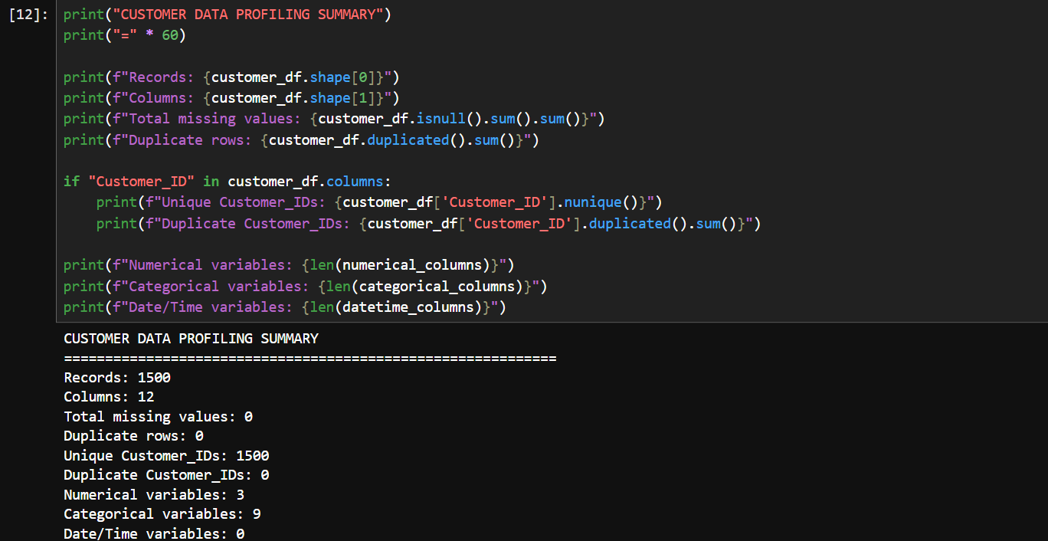

Evidence 2 — Transaction Data Profiling
Screenshot showing:
- Transaction dataset structure
- 12,000 records
- 11 columns
- Missing values
- Data types
- Unique transaction and customer counts

Figure 2: Transaction Data Profiling Evidence
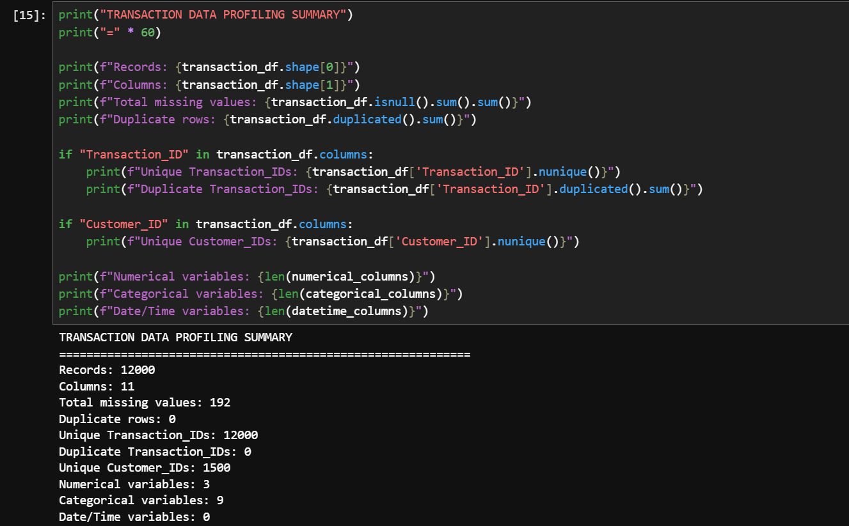

Evidence 3 — Dataset Relationship
Diagram showing:
Customer Data → Customer_ID → One-to-Many → Transaction Data

Figure 3: Customer–Transaction Dataset Relationship
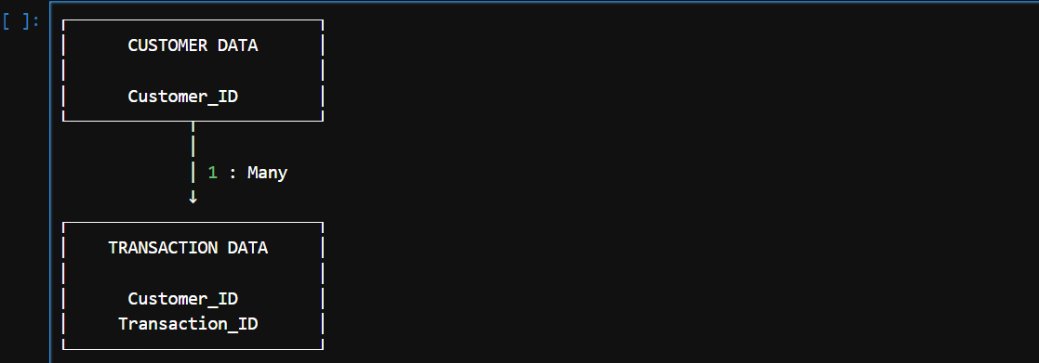

The Customer and Transaction datasets are linked using Customer_ID. The relationship is one-to-many because one customer can have multiple transaction records. This relationship will allow customer characteristics to be analysed alongside transaction behaviour in later stages of the project.

Evidence 4 — Dashboard Wireframe
Screenshot/image showing the proposed FinTrust Power BI dashboard layout, including KPI cards, filters and planned analytical visuals.
Figure 4: Proposed FinTrust Financial Intelligence Dashboard Wireframe
The wireframe presents the proposed structure of the FinTrust dashboard. The actual Power BI dashboard will be developed during the subsequent project stages after data preparation and analysis.

